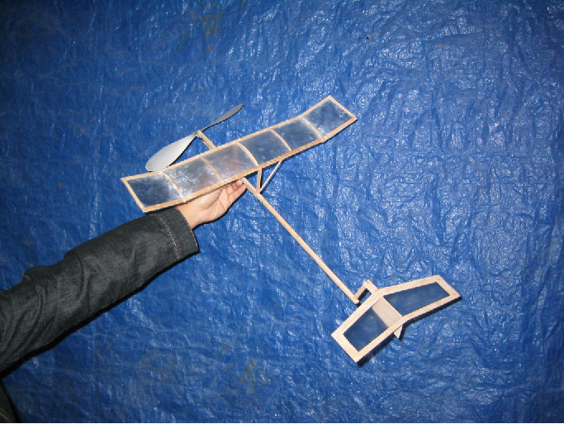
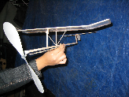
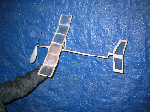
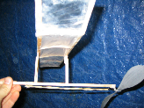
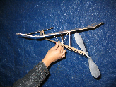

TEAM Z  Irene Chan  Sunny Johri  Jeffrey Miller  Eric Sherk  MAE 2  12/5/03 |  | INDOOR  FREE FLIGHT AIRPLANE

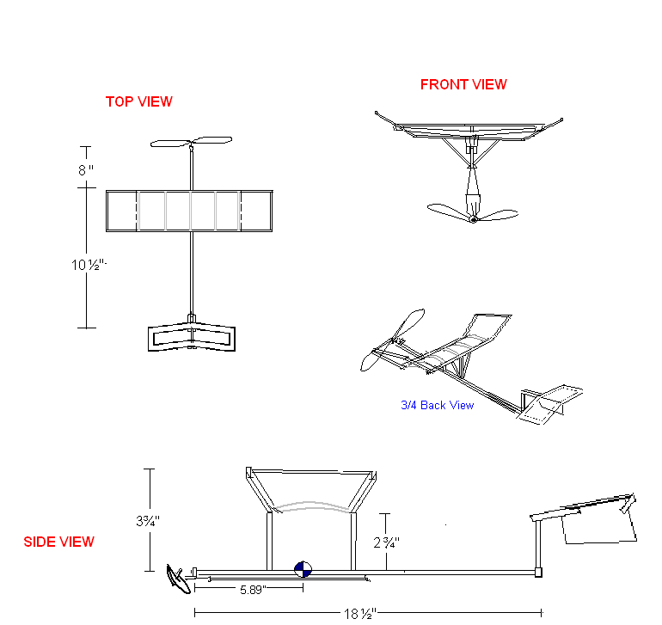Note: Not to scale

Performance Estimates
Theoretically the plane of this design should remain airborne at least 20 seconds. Trims were constantly furnished: adjusting the angle of incidence; positioning the tail to balance the loads at both ends of the motor stick, modifying the length of the struts and adjusting the amount of winding required for the motor. Under unforeseen circumstances, the rubber band motor became defective (it broke from excessive winding) and the propeller is no longer interchangeable after being bent permanently into position. The design of this plane focuses on maintaining lift during its flight and as a result, albeit the present minor limitations of the motor, the plane maintained altitude and completed two turns.

Designs and Calculations
After looking at gliders made in the past by others, we’ve decided the optimal design would include an asymmetrical, thin-cambered airfoil of the wing (like the first gliders ever made), a tipped dihedral, and a tail with a stab. The tilt of the empennage forces the tail down and the nose up, which maintains lift. Additionally, the 3° angle of incidence raises the wing and adds even more lift. To reduce the load and excessive drag, balsa wood has been utilized for all the framework (including struts) and superglue was used to assemble the framework. The wing and tail was covered with a skin of plastic film, blow-dried after using superglue to tighten the coverage around the structures.

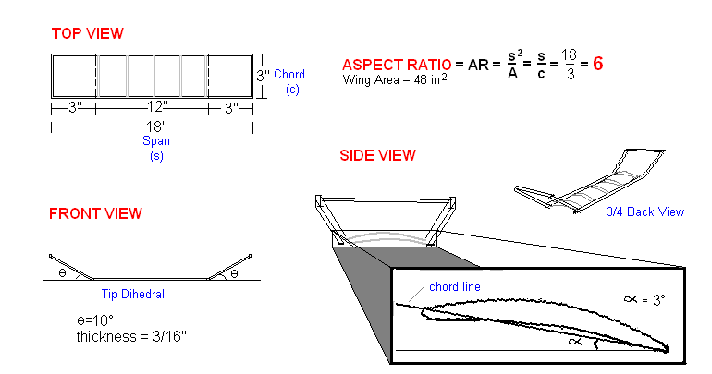Wing
Note: Not to scale
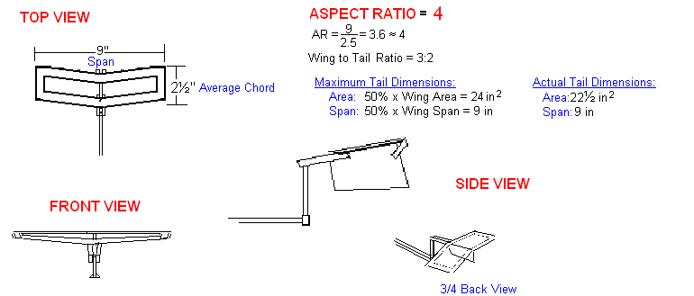
Tail
Note: Not to scale

Center of Gravity

Balance Point: Propeller-Wing
Reference Point: Propeller; Distance between: 8”
Structure | Weight (g) | Arm length (in) | Moment
Propeller | 5.3 | 0 | 0
Wing | 9.7 | 8 | 77.6
Total | 15.0 |  | 77.6
Balance Point = Moment ÷ Total Weight = 77.6÷ 15 = 5.73 in

Balance Point: Wing-Tail
Reference Point: Wing; Distance between: 10.5”
Structure | Weight (g) | Arm length (in) | Moment
Wing | 9.7 | 0 | 0
Tail | 4.6 | 10.5 | 48.3
Total | 14.3 |  | 48.3

Balance Point = Moment ÷ Total Weight = 48.3÷ 14.3 = 3.37 in

Balance Point: Propeller-Tail
Reference Point: Propeller; Distance between: 18.5”
Structure | Weight (g) | Arm length (in) | Moment
Propeller | 5.3 | 0 | 0
Tail | 4.6 | 18.5 | 85.1
Total | 9.9 |  | 85.1
Balance Point = Moment ÷ Total Weight = 85.1÷ 9.9 = 8.59 in

CG Location = Average of the balance points = 5.89 in from propeller’s end

(5.73 in + 3.37 in + 8.59 in)/3 = 5.89 in

